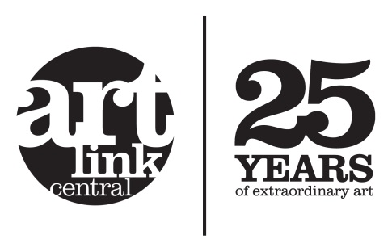

Job Description: Programme Artist - Visual Arts (Fixed-Term) – Mental Health Social Prescription Service (7 hours/week)
Fixed-Term Contract of 3 months to cover extended leave (potential may exist to extend to 6 months)
- The Programme Artist - Visual Arts will work specifically on the Artspace Mental Health Social Prescription Service programme that is delivered as part of Artlink Central's stream within Stirling Council’s Mental Health Strategy (Social Care Provision). They will be lead artist for the project and duties include the following:

- Marketing the services to third sector organisations, health and social care departments
- Following up referrals with referrers
- Designing and prepping the programme blocks
- Booking appropriate spaces and venues
- Delivering the programme blocks on a weekly basis
- Responding to any incoming referrals
- Corresponding with participants, advising on the blocks, sign posting on etc.
- Complete the Evaluations with participants (1 to 1)
- Keep up to date with Arts opportunities
- Reviewing opportunities for and organising exhibitions of participant work
- Ordering materials etc.
- Other duties as required
.
- Administrative Skills are integral to the post such as maintaining schedules, disseminating information, liaising with various stakeholders, producing documents and maintaining project files under the supervision of the Director and the Artistic Programmer.

- In regard to the Artspace programme Artlink Central is bound by policy and procedures relating to an individual’s confidentiality as outlined by Stirling Council Social Care Provision. The Programme Artist - Visual Arts will be required to handle some sensitive information and be aware of confidentiality requirements.

- The Artistic Practitioner will be required to undergo a successful application to Disclosure Scotland for an Enhanced Disclosure. This application process will be managed by Artlink Central.

